
Symbiosis Institute of Technology, Pune
Faculty of Engineering
CSE- Academic Year 2026-27
Java Programming – Lab Batch 2025-29
Lab Assignment No:- 17
Name of  Student | ANIRUDDHA PRATAP SINGH
PRN No. | 25070122247
Batch | CSE-c2
Class | PROGRAMMING WITH JAVA
Academic  Year &  Semester | 2nd-year and 3rd-semester
Title of  Assignment: | Write a Java program to demonstrate the use of Swing and Applets
Problem  Statement | Write a Java program to demonstrate the use of Swing and Applets
Learning  objective | To develop graphical user interfaces using Swing components and Applets.
Theory | Swing is Java's GUI toolkit that provides lightweight components such as buttons, labels,text fields, and menus. Applets were small Java programs embedded in web pages for interactive applications. Although Applets are obsolete, Swing remains an important framework for desktop application development. Swing supports platform-independent graphical interfaces.

Programme | 1. Create a simple Student Registration Form GUI using Swing. =>import javax.swing.*;  public class E1 {  public static void main(String[] args) {  JFrame frame = new JFrame("Student Registration Form");  JLabel nameLabel = new JLabel("Student Name:");  JTextField nameField = new JTextField();  JLabel rollLabel = new JLabel("Roll Number:");  JTextField rollField = new JTextField();  JLabel courseLabel = new JLabel("Course:");  JTextField courseField = new JTextField();  JButton button = new JButton("Register");  nameLabel.setBounds(30, 30, 120, 25);  nameField.setBounds(150, 30, 180, 25);  rollLabel.setBounds(30, 70, 120, 25);  rollField.setBounds(150, 70, 180, 25);  courseLabel.setBounds(30, 110, 120, 25);  courseField.setBounds(150, 110, 180, 25);  button.setBounds(120, 150, 120, 30);  frame.add(nameLabel);  frame.add(nameField);  frame.add(rollLabel);  frame.add(rollField);  frame.add(courseLabel);  frame.add(courseField);  frame.add(button);  button.addActionListener(e -> {

String name = nameField.getText();
String roll = rollField.getText();
String course = courseField.getText();
JOptionPane.showMessageDialog(
frame,
"Student Name: " + name +
"\nRoll Number: " + roll +
"\nCourse: " + course
);
});
frame.setSize(380, 240);
frame.setLayout(null);
frame.setDefaultCloseOperation(JFrame.EXIT_ON_CLOSE); frame.setVisible(true);
}
}
2.Create a simple Employee Registration Form using Java Swing GUI that takes
employee details such as Employee ID, Name, Department, and Salary. Display the
entered information in a dialog box
=>import javax.swing.*;
public class E2 {
public static void main(String[] args) {
JFrame frame = new JFrame("Employee Registration Form");
JLabel idLabel = new JLabel("Employee ID:");
JTextField idField = new JTextField();
JLabel nameLabel = new JLabel("Name:");
JTextField nameField = new JTextField();
JLabel deptLabel = new JLabel("Department:");
JTextField deptField = new JTextField();
JLabel salaryLabel = new JLabel("Salary:");
JTextField salaryField = new JTextField();

JButton button = new JButton("Register");
idLabel.setBounds(30, 30, 120, 25);
idField.setBounds(150, 30, 180, 25);
nameLabel.setBounds(30, 70, 120, 25);
nameField.setBounds(150, 70, 180, 25);
deptLabel.setBounds(30, 110, 120, 25);
deptField.setBounds(150, 110, 180, 25);
salaryLabel.setBounds(30, 150, 120, 25);
salaryField.setBounds(150, 150, 180, 25);
button.setBounds(120, 190, 120, 30);
frame.add(idLabel);
frame.add(idField);
frame.add(nameLabel);
frame.add(nameField);
frame.add(deptLabel);
frame.add(deptField);
frame.add(salaryLabel);
frame.add(salaryField);
frame.add(button);
button.addActionListener(e -> {
String id = idField.getText();
String name = nameField.getText();
String department = deptField.getText();
String salary = salaryField.getText();
JOptionPane.showMessageDialog(
frame,
"Employee ID: " + id +
"\nName: " + name +
"\nDepartment: " + department +
"\nSalary: ₹" + salary
);
});

frame.setSize(380, 280);
frame.setLayout(null);
frame.setDefaultCloseOperation(JFrame.EXIT_ON_CLOSE); frame.setVisible(true);
}
}
Output  Screenshots  (if applicable) | E1=>  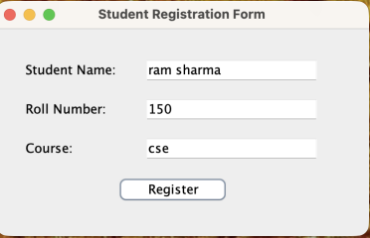

E2=>
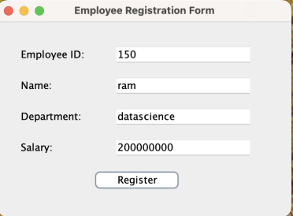
Github  Screenshot | 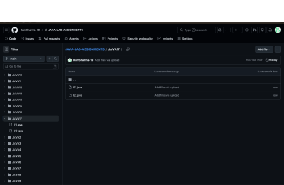
Conclusion | In this assignment, Java Swing GUI programming was successfully implemented by creating Student and Employee Registration Forms. The programs used JFrame, JLabel, JTextField, JButton, and JOptionPane to create an interactive graphical user interface. User details were accepted through text fields and displayed using a dialog box when the Register button was clicked. This experiment helped in understanding the basics of GUI components, event handling, user input, and interactive application development in Java.

